NANNY PAWS CARE
A Cross-Platform Pet Sitting and Management Application
USER MANUAL
Pet Owner and Pet Sitter · Mobile Application
A Capstone Project Documentation
Presented to the Faculty of the College of Computer Studies, Silliman University
Prepared by Aki B. Maeda, Sherall Bless A. Abiera, Voughn John Zoe N. Villalon
September 2026 (modules updated 9/17/2026)

PART 1 — PET OWNER
The pet owner uses the mobile application to register, maintain pet records, request pet-sitting services, pay after completion, and correspond with the assigned sitter.
1.1 Getting started and onboarding
Purpose. The first launch presents three introduction screens. After they are finished or skipped, the application opens the Login page.
Procedure
Step | Action
1 | Install and open the Nanny Paws mobile application.
2 | Swipe through Faithful Friends for Pets, Book Pet Care Anytime, and Loving Care You Can Trust, or tap Skip.
3 | On the last introduction page, continue to the Login screen titled Welcome to Nanny Paws!

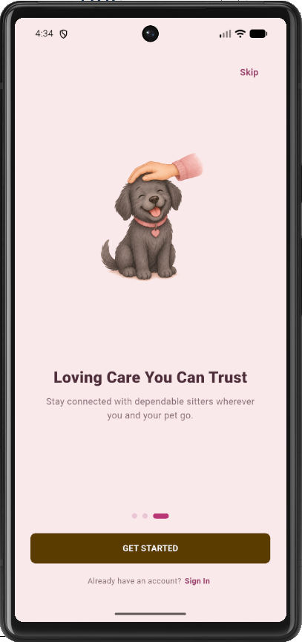
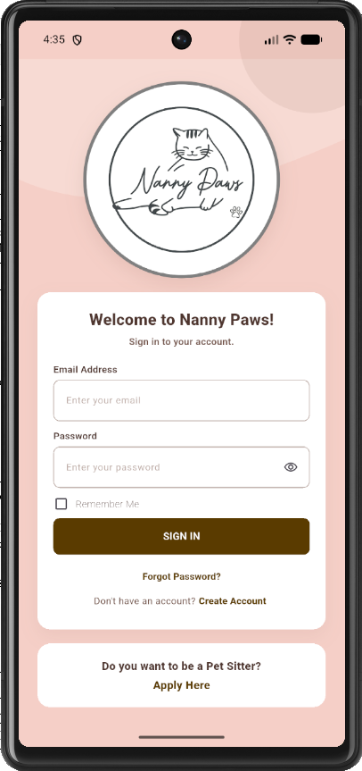
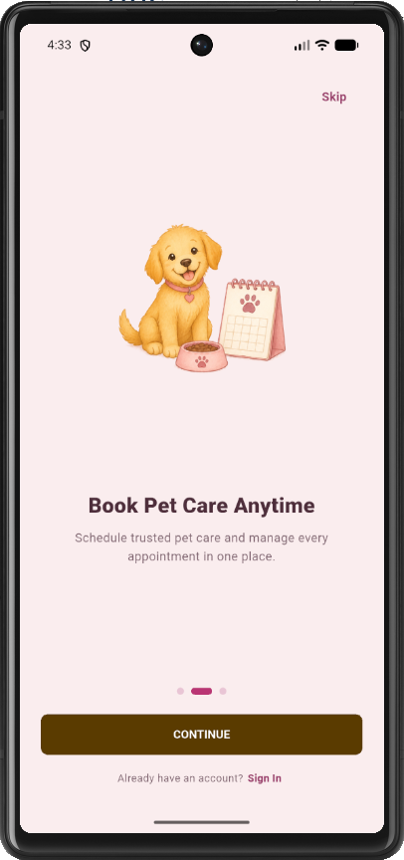
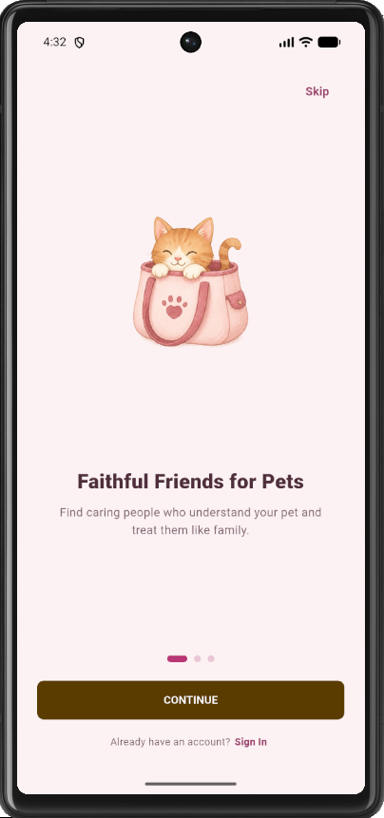
Figure 1.1. Owner onboarding screens
1.2 Creating a pet owner account
Purpose. Only pet owners create an account from Sign Up. Pet sitters use Apply Here instead of this form.
Procedure
Step | Action
1 | On the Login page, open Create your Account / Sign Up.
2 | Enter First Name, Last Name, Username, Email Address, Contact Number, Password, and Confirm Password.
3 | Tap SIGN UP.
4 | Read the Account Created message. Open the verification email, including the Spam folder, and verify the address before signing in.

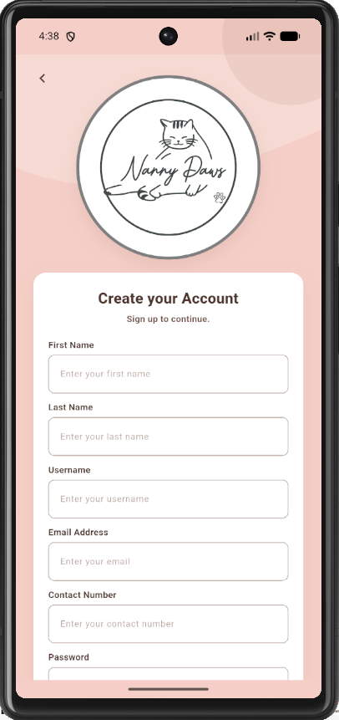
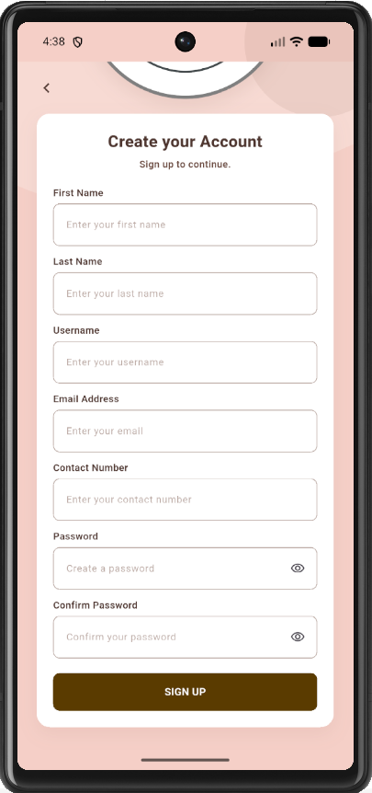
Figure 1.2. Create your Account (Sign Up) page
Note. Empty required fields display Missing Information. An email that is already registered displays Check Your Account and returns the user to Login.
1.3 Signing in and recovering a password
Purpose. A verified pet owner signs in with email and password. An unverified address cannot complete login.
Procedure
Step | Action
1 | On the Login page, enter Email Address and Password.
2 | Optionally enable Remember Me, then tap SIGN IN.
3 | A verified owner is taken to the owner Home screen.
4 | If the password is incorrect, choose TRY AGAIN or RESET PASSWORD.
5 | To reset a password, tap Forgot Password?, enter the verified email, open the email link, and enter the new password twice.

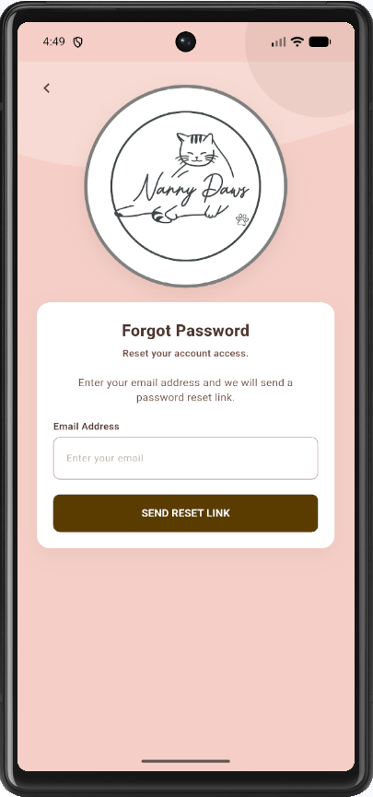
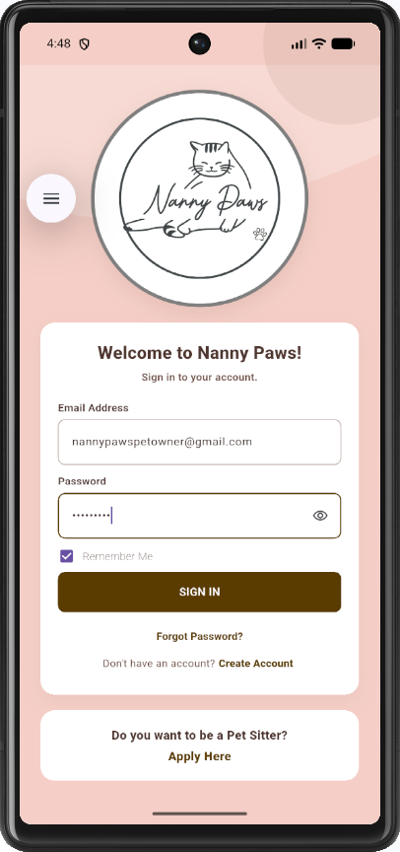
Figure 1.3. Pet Owner Login page and Forgot Password page
1.4 Home screen and navigation
Purpose. The owner shell provides five destinations on the bottom navigation. Home also highlights Care Concierge, Drop-in Visits, and Boarding service information.
Procedure
Step | Action
1 | Confirm that Home shows an overview of the account, including unpaid completed bookings when payment is due.
2 | Use Bookings to open the booking list and sitter search.
3 | Use My Pets to maintain pet and vaccination records.
4 | Use Messages to chat with a sitter who already shares a booking.
5 | Use Menu to open the profile and to sign out.

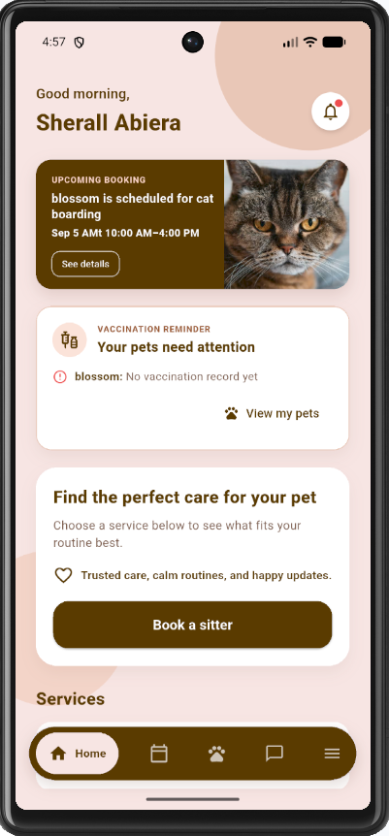
Figure 1.4. Pet Owner Home screen with bottom navigation
1.5 Managing pets
Purpose. At least one pet must be registered before a booking can be created.
Procedure
Step | Action
1 | Tap My Pets, then tap Add New Pet.
2 | Enter name, type (Dog or Cat), breed, gender, date of birth, weight, optional notes, and an optional photo.
3 | Tap Add Pet. The pet appears in My Pets. Vaccination status remains Not Vaccinated until a record is added.
4 | Open a pet later and use Edit Pet to change details, then tap Update Pet.

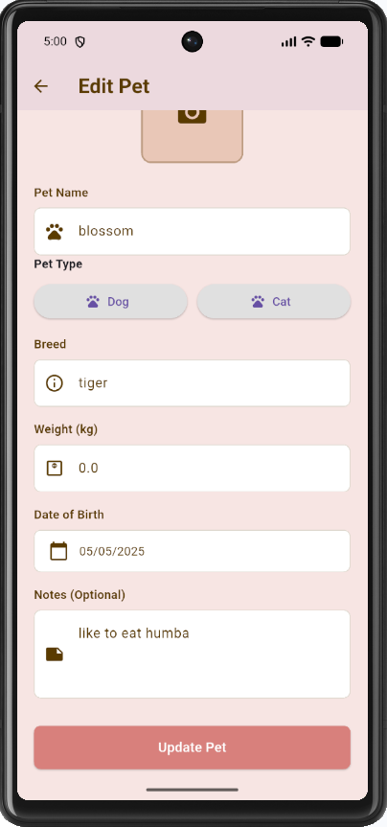
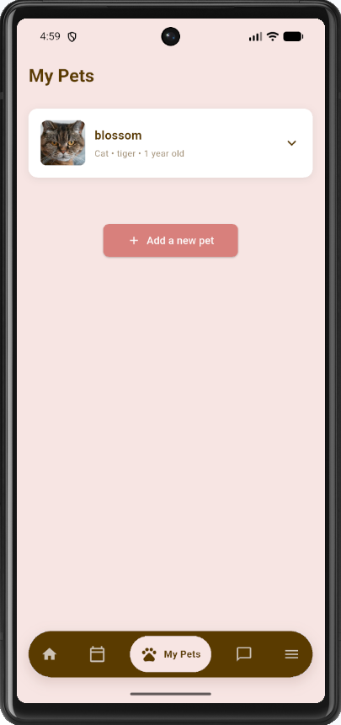
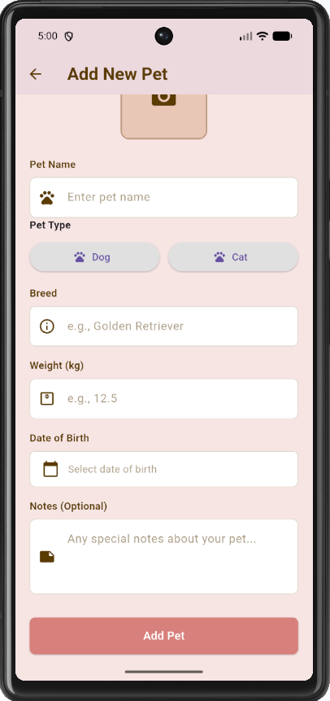
Figure 1.5. My Pets list, Add New Pet form, and Update Pet form
1.6 Adding a vaccination record
Purpose. Vaccination records are stored per pet and may be reviewed by the assigned sitter.
Prerequisites. The selected pet already exists in My Pets.
Procedure
Step | Action
1 | Open a pet from My Pets.
2 | Open Add Vaccination.
3 | Enter Vaccine Name, type (Core or Non-Core), Dose Number, date administered, and next due date.
4 | Upload the vaccination card image and tap Save Vaccination.

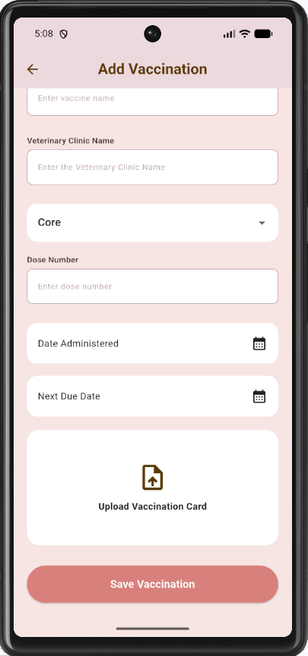
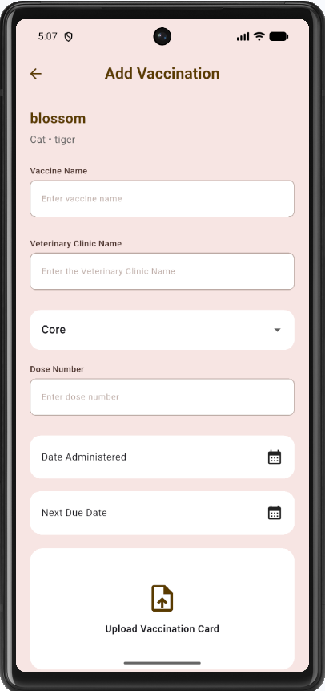
Figure 1.6. Add Vaccination page
1.7 Finding a sitter and creating a booking
Purpose. A submitted booking remains Pending until the administrator confirms it. Payment is not collected until the sitter marks the visit Completed. Bookable prices come from the service catalog (Drop-in, Boarding, Care Concierge).
Procedure
Step | Action
1 | Open Bookings or the sitter map/list and select an approved sitter whose preferred pet type matches the pet.
2 | Choose Whole day or Hourly booking mode.
3 | Select start date, end date, and (for Hourly) times inside the sitter’s available windows.
4 | Choose a catalog service. The amount is computed automatically.
5 | Select the pet and optionally select Additional Services offered by the sitter (paid directly to the sitter).
6 | Enter optional instructions.
7 | Tap View service waiver, read it, and check I have read and agree to the service waiver.
8 | Upload the signed waiver as a PDF.
9 | Tap Book Appointment. Status is Pending. Payment status is Not Due.

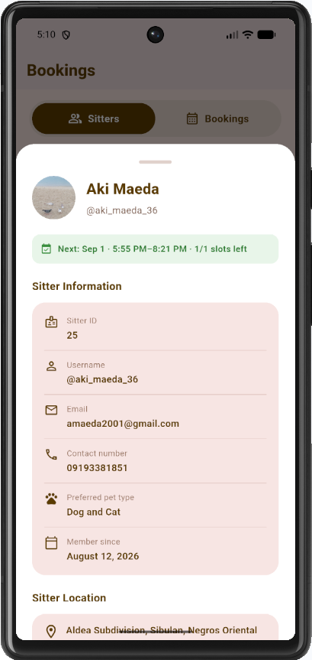
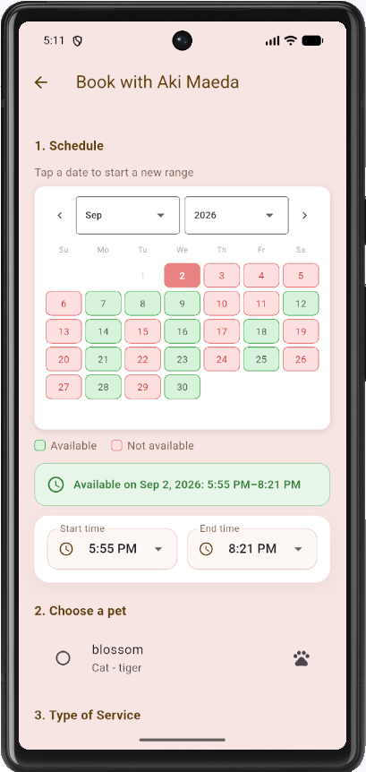
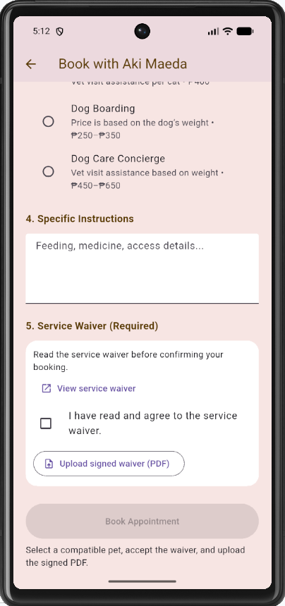
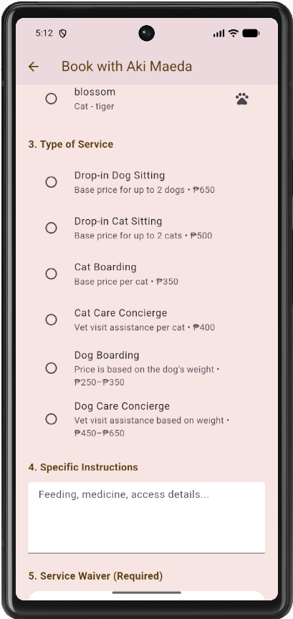
Figure 1.7a. Available pet sitters and Book Appointment form
Note. Book Appointment remains disabled until a compatible pet, a valid schedule, waiver acceptance, and a PDF are present.
1.8 Viewing, cancelling, or rescheduling a booking
Purpose. The owner may inspect every request, cancel a Pending booking, or propose a new schedule.
Procedure
Step | Action
1 | Tap Bookings to list the owner’s requests. Filter by Confirmed/Approved, Completed (Paid/Unpaid), or Cancelled as needed.
2 | Open a Pending booking to cancel or reschedule if needed.
3 | Tap Reschedule, choose a new available date and time, and tap Save Schedule. The booking returns to Pending for administrator review.

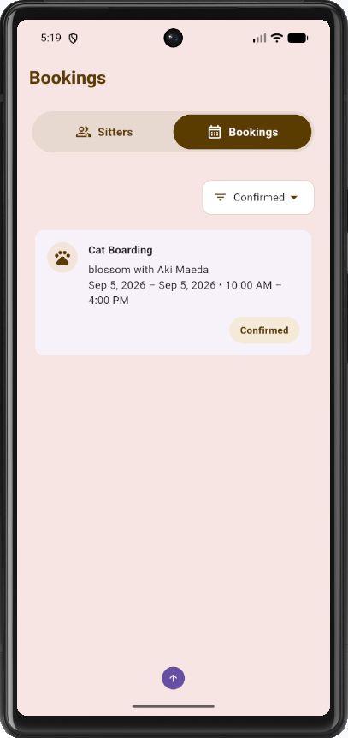
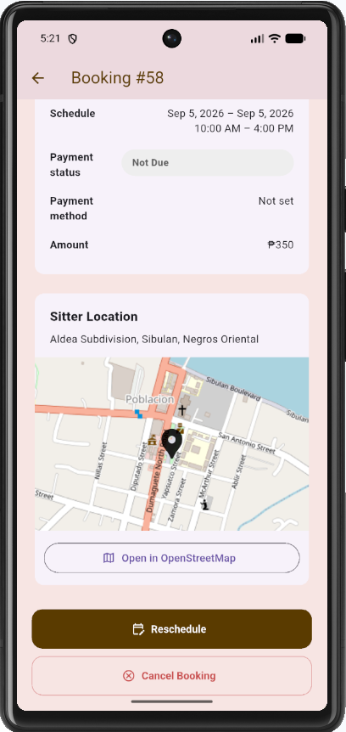
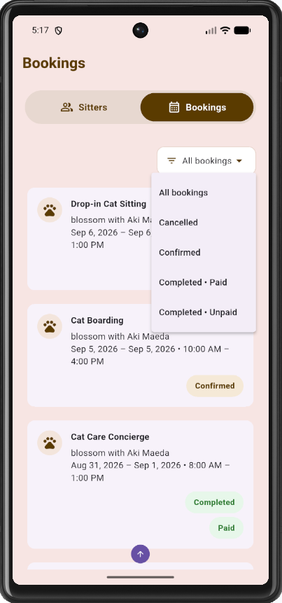
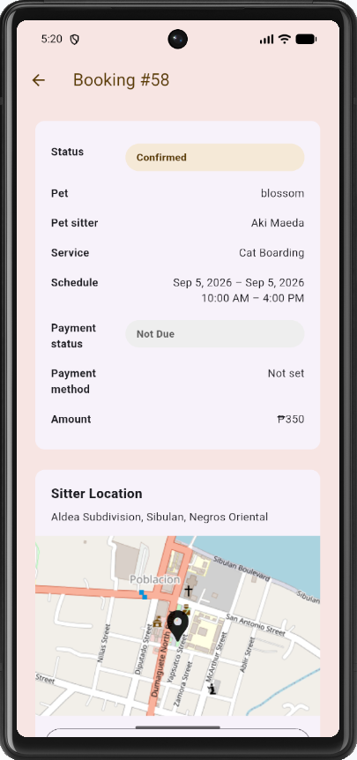
Figure 1.8. Owner Bookings list and booking details
1.9 Paying after the service is completed
Purpose. Payment is available only when the sitter has marked the booking Completed and payment status is Unpaid.
Procedure
Step | Action
1 | Open the completed unpaid booking.
2 | Tap Pay Now.
3 | Choose GCash to open the Complete Payment screen, pay using the QR code, upload the screenshot, and tap Submit Proof of Payment. Payment status becomes Pending Review.
4 | Or choose Cash. Payment status becomes Awaiting Cash Confirmation (Cash Pending) until the administrator confirms receipt.

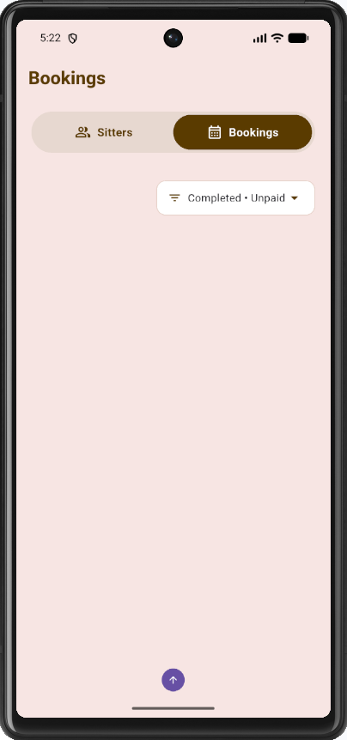
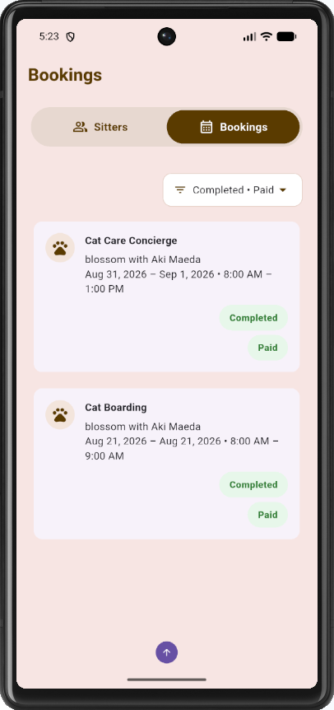
Figure 1.9. List of Unpaid and Paid Completed Bookings
Note. Pay Now is not shown on Pending or Confirmed bookings. Payment status remains Not Due until the visit is completed.
1.10 Messages and notifications
Purpose. Messaging is limited to an owner and a sitter who already share a booking.
Procedure
Step | Action
1 | Tap Messages and open the conversation with the assigned sitter.
2 | Type a text message and send it. Attach a photo from the gallery when an image is required.
3 | Open Notifications to review booking status changes or vaccination due alerts.

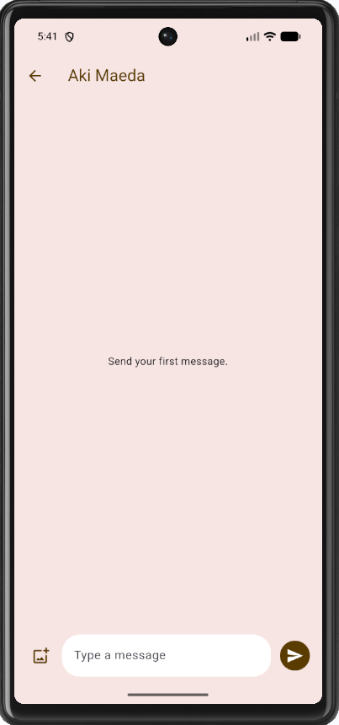
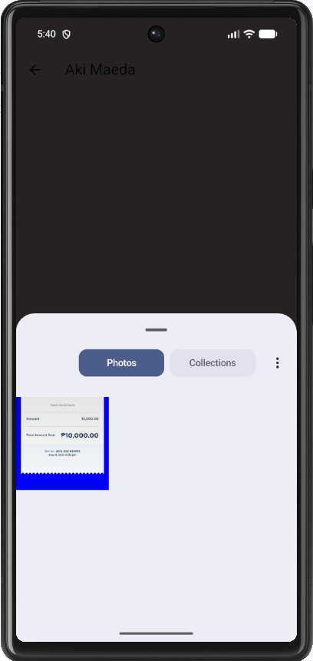
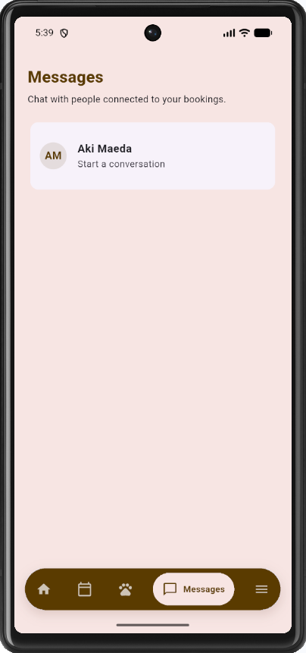
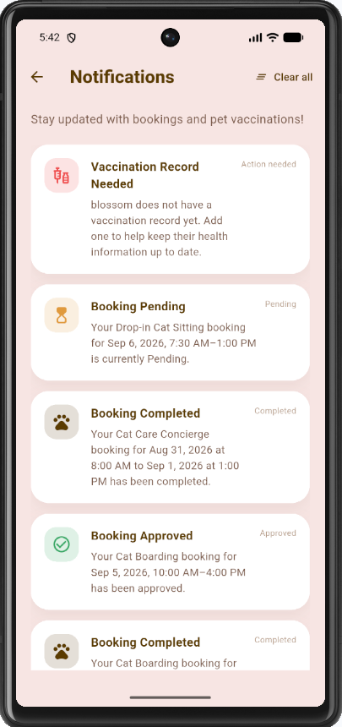
Figure 1.10. Owner Messages conversation and Notifications
1.11 Leaving feedback
Purpose. After completion, the owner may rate the sitter. The administrator can read the same record on the web Feedbacks page.
Prerequisites. The booking status is Completed and feedback has not yet been submitted for that visit.
Procedure
Step | Action
1 | Open the completed booking.
2 | Tap Leave Feedback.
3 | Select a rating from 1 to 5 stars, enter comments, and submit.

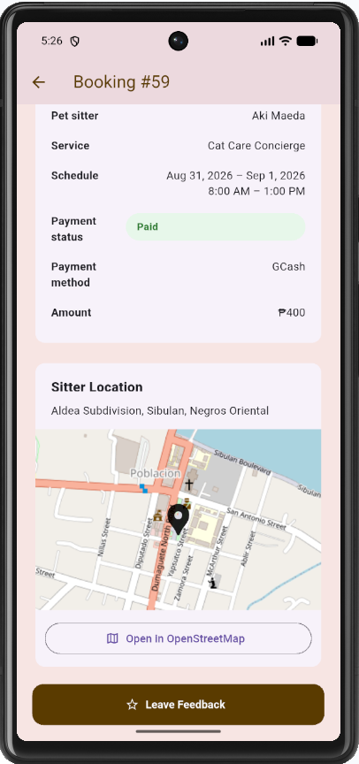
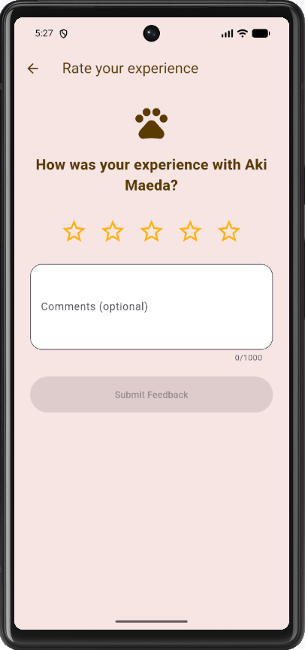
Figure 1.11. Leave Feedback page
1.12 Profile and Logout
Purpose. The owner maintains name, email, phone, and photograph from Menu. Menu also opens Help Center, Terms & Conditions, Privacy Policy, and About Nanny Paws.
Procedure
Step | Action
1 | Tap Menu, then tap the profile account card.
2 | Tap Edit. Update full name, email, phone, and photograph as required.
3 | Tap Save Changes.
4 | On Menu, open Help / Terms / Privacy / About as needed, or tap Log out and confirm to return to the Login page.

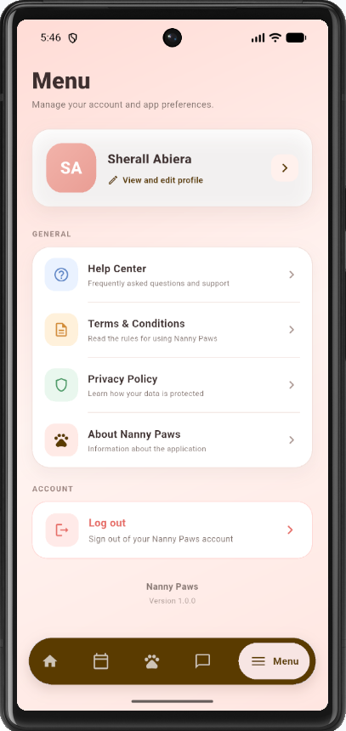
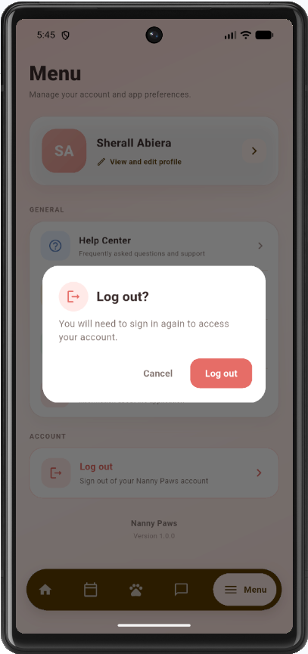
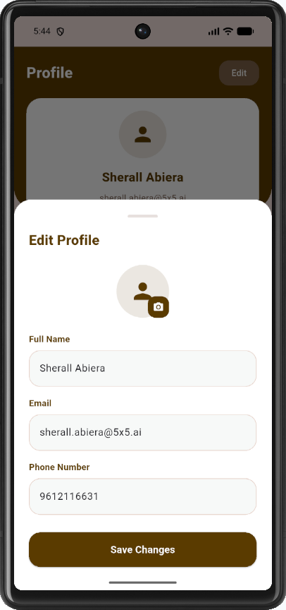
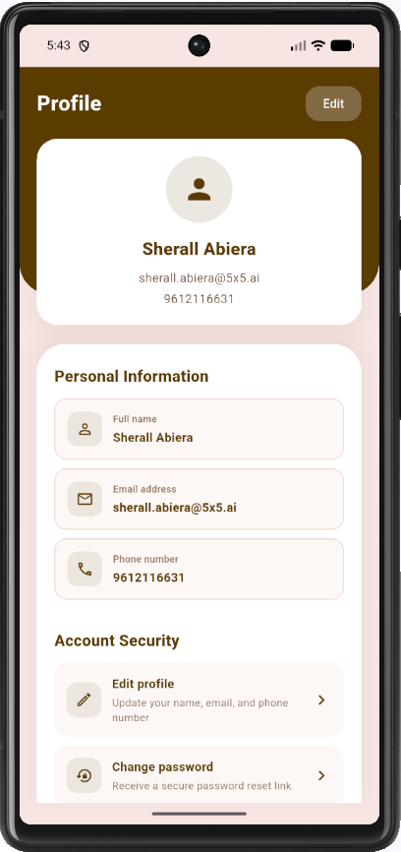
Figure 1.12. Owner Menu, Profile Page, Edit Profile and Logout

PART 2 — PET SITTER
The pet sitter applies from the Login page. After the administrator accepts the application, the sitter signs in to review assigned bookings, complete visits, maintain availability, manage personal services, and review earnings.
2.1 Applying to become a pet sitter
Purpose. Sitters are not created from the owner Sign Up form. Apply Here submits a Pending application for administrator review.
Procedure
Step | Action
1 | On the Login page, tap Apply Here under Do you want to be a Pet Sitter?
2 | Enter First Name, Last Name, Email Address, Contact Number (09XXXXXXXXX), address, Negros Oriental postal code, and Date of Birth (18 years or older).
3 | Select preferred pet type: Dogs, Cats, or Both.
4 | Select preferred days, Start time, and End time.
5 | Upload one or more photographs of the pet place and a PDF resume not larger than 5 MB.
6 | Tap Apply. The application is stored as Pending. Do not attempt sitter login until the administrator accepts the record.

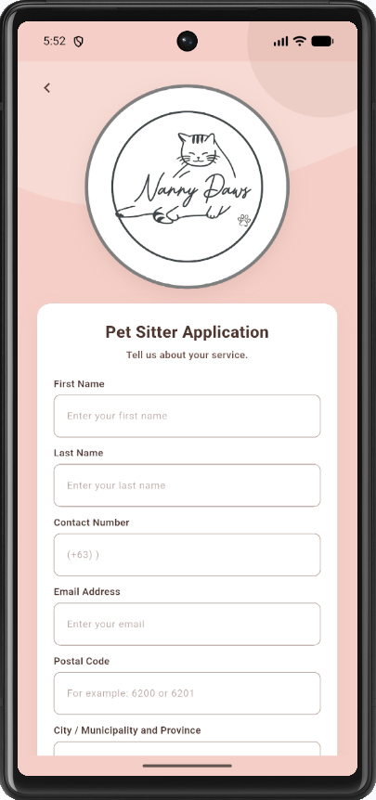
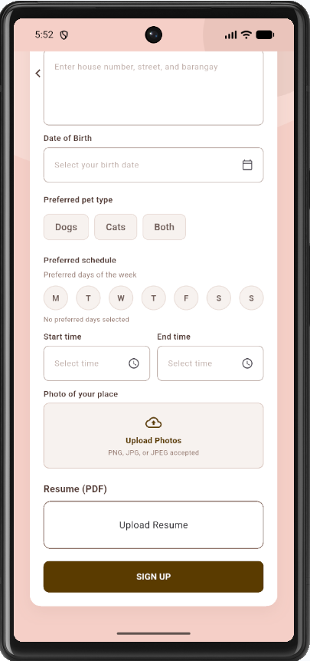
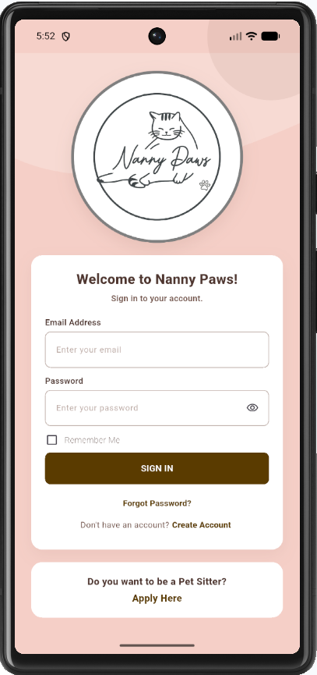
Figure 2.1. Pet Sitter Application page
Note. An invalid email, missing schedule, missing place photographs, or a non-PDF resume prevents submission.
2.2 Signing in after administrator acceptance
Purpose. Acceptance creates the PET SITTER account. Sign in with the application email and the password issued at acceptance. Only one active device session is kept for a sitter account.
Procedure
Step | Action
1 | Open the Login page.
2 | Enter the sitter email and the issued password.
3 | Tap SIGN IN. The sitter Home (assigned bookings) is displayed. The owner Home is not shown.
4 | Confirm the sitter navigation: Home (bookings), Bookings (availability), Messages, Notifications, and Menu.

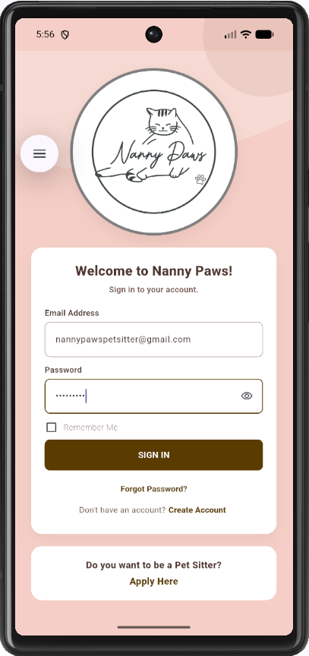
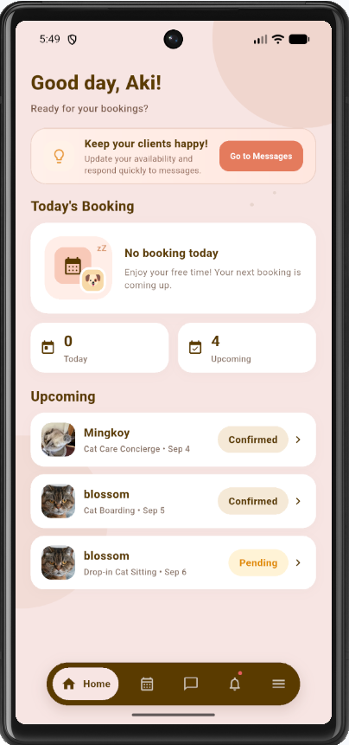
Figure 2.2. Pet Sitter Home after acceptance
Note. A Pending applicant cannot sign in as a sitter.
2.3 Reviewing assigned bookings
Purpose. The sitter sees only bookings assigned to that account.
Procedure
Step | Action
1 | On Home, review today’s and upcoming jobs.
2 | Open a booking to view owner, pet, schedule, service, add-ons, and instructions.

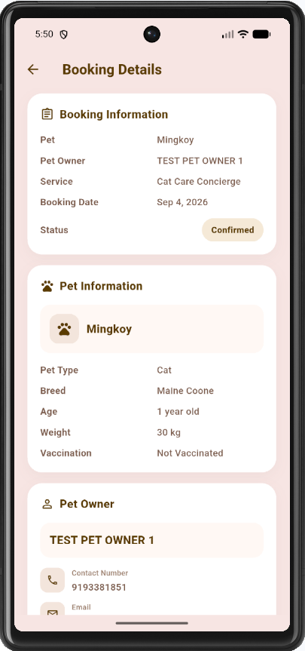
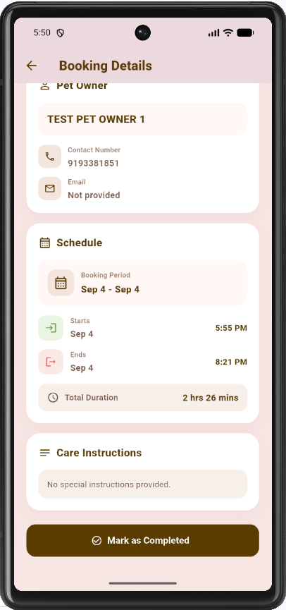
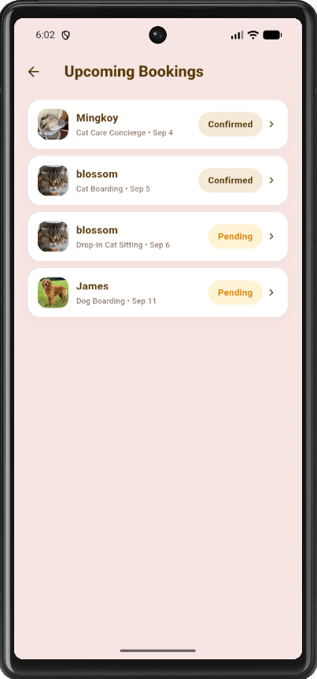
Figure 2.3. Sitter assigned bookings
2.4 Completing a booking
Purpose. After the visit ends, the sitter marks the booking Completed so the owner can pay.
Procedure
Step | Action
1 | Open a Confirmed booking details page.
2 | Tap Mark as Completed and confirm.
3 | Confirm booking status is Completed and payment status becomes Unpaid.

Figure 2.4. Completing a booking
2.5 Managing availability
Purpose. The Bookings tab opens the availability calendar used by owners when scheduling.
Procedure
Step | Action
1 | Tap Bookings on the sitter bottom navigation.
2 | Add, edit, or delete availability windows (date/time and capacity).
3 | Confirm existing bookings appear on the calendar dates.

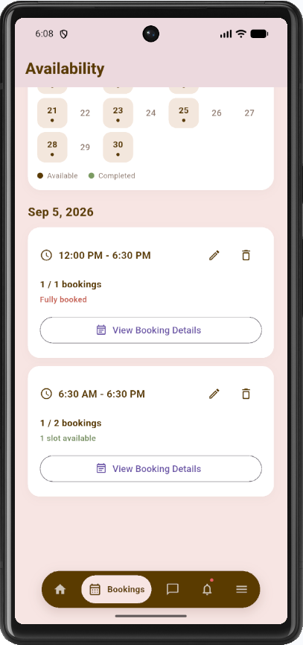
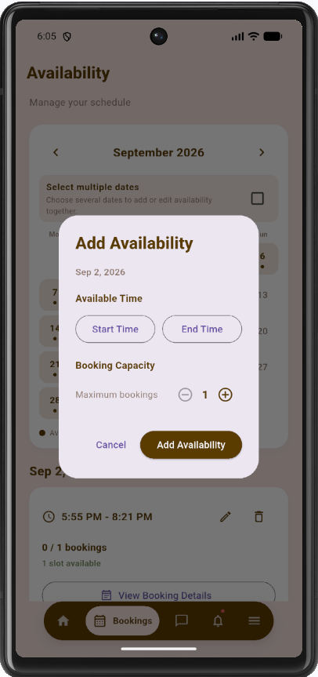
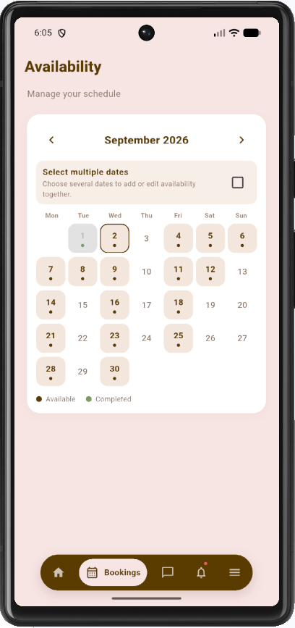
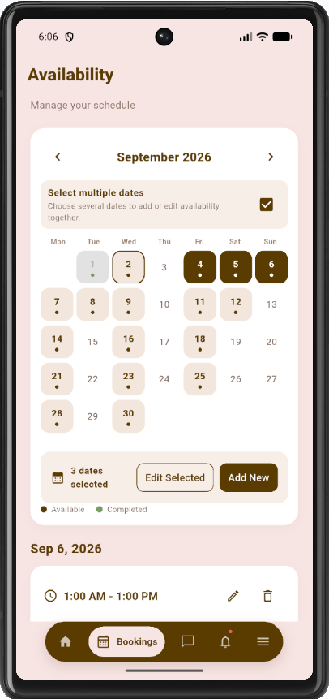
Figure 2.5. Sitter availability calendar
2.6 Messages and notifications
Purpose. The sitter messages owners who share a booking and reviews booking status notifications.
Procedure
Step | Action
1 | Tap Messages and open an owner conversation.
2 | Type a reply and send it. Attach a photo when needed.
3 | Open Notifications to review confirmed, completed, or cancelled booking updates.
4 | Tap Clear All and confirm if the notification list should be emptied. Bookings themselves are not deleted.

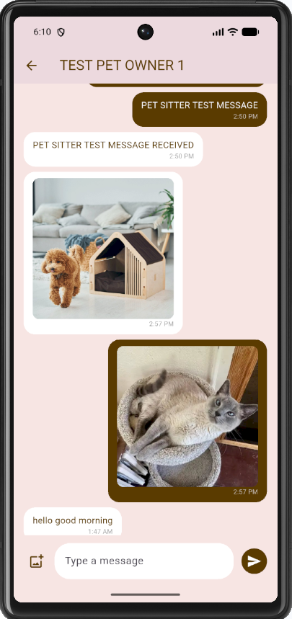
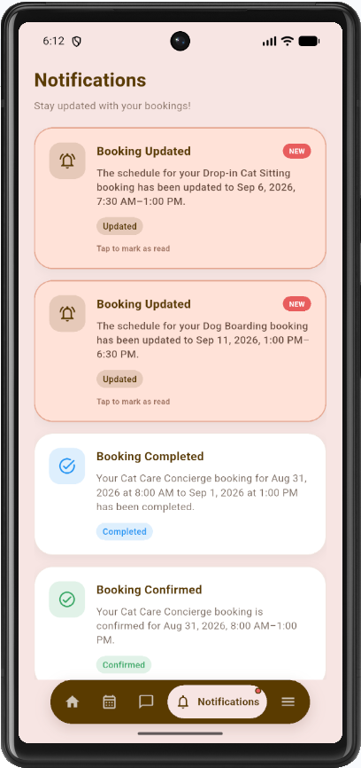
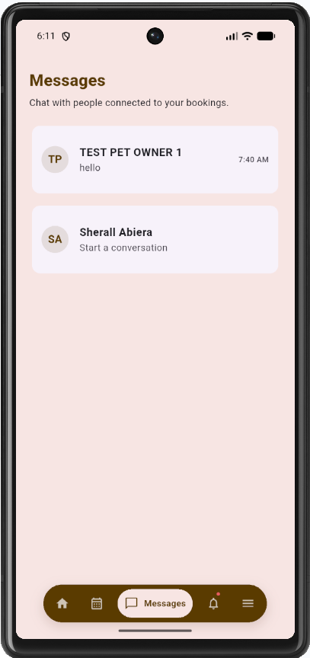
Figure 2.6. Sitter Messages and Notifications
2.7 Profile, services, information pages, and sign-out
Purpose. The sitter maintains profile information from Menu, manages personal additional services on the Profile Services tab, and may open information pages without changing records.
Procedure
Step | Action
1 | Tap Menu, then tap the profile card.
2 | Tap Edit. Update name, contact, address, and photograph, then tap Save Changes.
3 | Open the Services tab to review official Nanny Paws services and to add, edit, or remove My Additional Services.
4 | From Menu, open Help Center, Terms & Conditions, Privacy Policy, and About Nanny Paws as required.
5 | Tap Log out and confirm to return to the Login page.

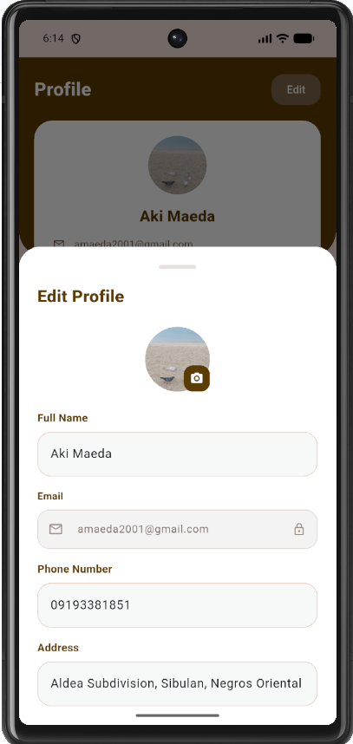
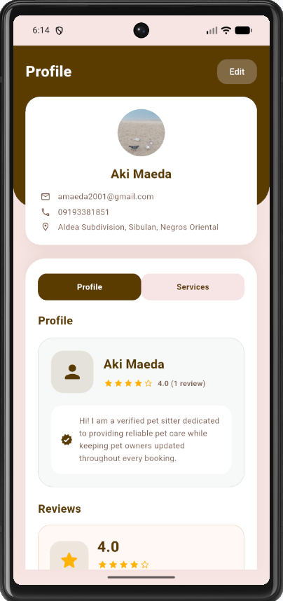
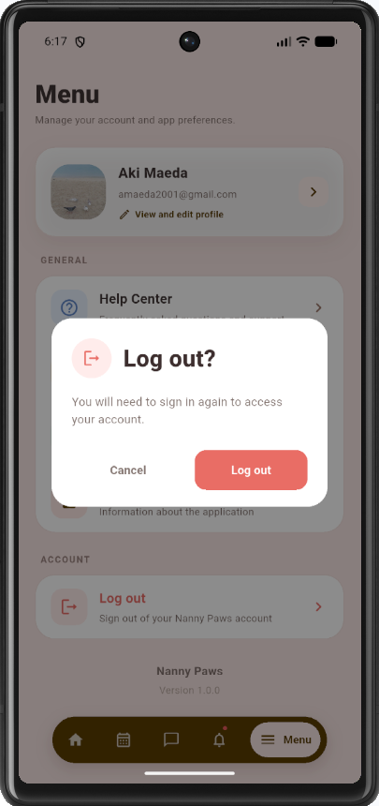
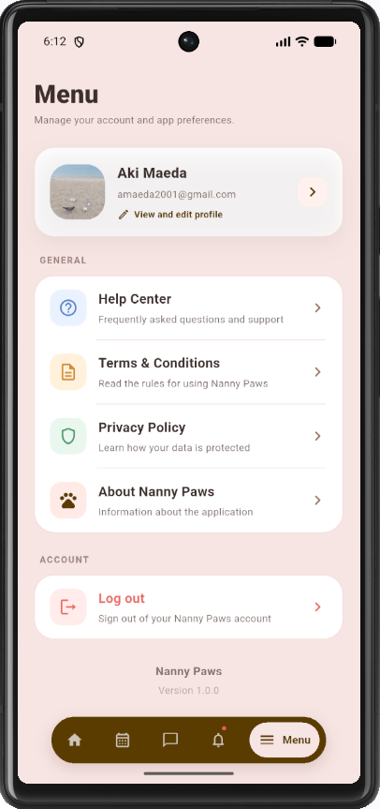
Figure 2.7. Menu, Sitter Profile, Services, and Logout
2.8 Earnings
Purpose. Earnings shows the sitter wallet totals and transaction history after the business finalizes Completed+Paid bookings. Amounts use the revenue share configured in administrator Maintenance.
Procedure
Step | Action
1 | Tap Menu, then tap Earnings.
2 | Review Available earnings and Pending payout.
3 | Filter the transaction history (All / Received / Pending) or search by booking or service.
4 | Open a transaction to view service total, your percentage, and your earnings.

[Figure 2.8. Sitter Earnings wallet and transaction history]
Note. Completed jobs appear here after the booking is Paid and the business earnings snapshot is recorded.

